2019-2020

Memorandum of Agreement

ARKANSAS AWARE Advancement
School Mini Grant Project

GUIDELINES
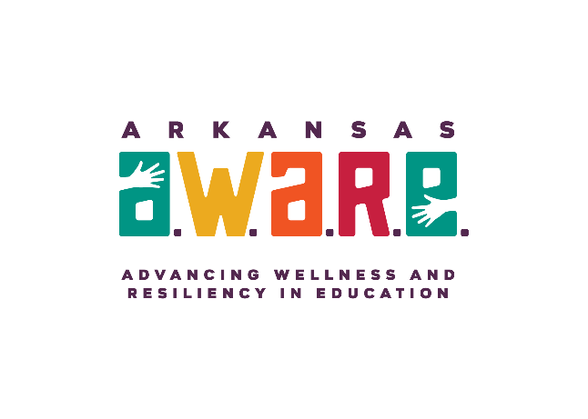

AGREEMENT DEADLINE
Completed agreement must be received by the Division of Elementary and Secondary Education on or before Friday, August 23, 2019.

Division of Elementary and Secondary Education
Arkansas AWARE Advancement
School Mini Grant Project
2019 - 2020
PURPOSE
The Arkansas AWARE Advancement Mini-Grant Project is an opportunity for Arkansas Public School Districts participating in the Substance Abuse and Mental Health Services Administration RFA-SM-18-006 AWARE (Advancing Wellness And Resiliency in Education) State Education Agency Grant to support districts in their efforts in providing mental health care awareness and trauma informed practices among students and staff.

ELIGIBLE ENTITIES
Arkansas public school districts who meet all of the following criteria are eligible to apply:

- The organization is an Arkansas public school district.
- The district agrees to conclude the goals and objectives from the AWARE Advancement project in the target school’s health and wellness school improvement plan.
- The district has obtained the bronze level in the School Health Assessment and Performance Evaluation (SHAPE) System. (https://theshapesystem.com/)

AGREEMENT GUIDELINES
Districts intending to promote school mental health awareness or trauma informed programming may apply for up to $10,000. The AWARE Advancement schools mini-grant funds will be issued in one lump sum payment.

Quarterly progress and an annual financial report will be required NOTE: During the agreement period, failure to achieve benchmarks, have designated participants attend all training sessions, meetings and submit all required reports may result in termination of the agreement and financial support.

REPORTING & EVALUATION REQUIREMENTS
The district must report all data as required by DESE. Those reports include but are not limited to:
- Mid-year and year-end progress reports, due January 2020
- Year-end financial reports, due August 2020
Submission of all reports and data collection is mandatory.

PROFESSIONAL DEVELOPMENT REQUIREMENTS
A districts designated School-Based Mental Health (SBMH) Coordinator for each district is required to attend two required webinars for this project. Webinars dates will be released once awards are made available.

FUNDING CRITERIA AND GUIDELINES
The maximum grant award is $10,000 for one year of funding. Proposed costs must be considered reasonable and necessary to carry out the purpose and objectives of this agreement. Funds may be used only to supplement, not supplant, any federal or state mandates. These funds may not supplant existing services.

All grant funds must be expended according to the DESE approved budget by June 30th, 2020.
The grantees must meet the following criteria:
- Provide a district program that encompasses bringing awareness to mental health
- Document intervention activities and report progress; and
- Submit a summary report by August 9, 2020, to include:
  - End-of-Project Financial Report (this report must include an expenditure audit trail (EAT), along with a check for remaining balance if applicable)
  - End-of -Project Performance Objective

BUDGET CATEGORY/GUIDELINES
The following budget categories are available for this project funding.

PURCHASED SERVICES (63000)
Training and Conference Fees
Training and conference fees are expenses that are related only to professional development for SBMH staff (i.e., conference registration fees for health center core team).

TRAVEL (65800)
In-state Travel
Any expense directly related to SBMH staff to travel within the state of Arkansas to carry out related duties and requirements (i.e., mileage, lodging, meals, etc.).
Out-of-State Travel
Any expenses directly related to SBMH staff to travel outside the state of Arkansas to carry out related duties and requirements (i.e., mileage, lodging, airfare, meals, etc.)

SUPPLIES & MATERIALS (66000-67000)
General Supplies
Any single item purchased for the project for less than $1,000.

For technical assistance relative to the application, contact, via email or phone:

Arkansas AWARE State Project Coordinator: Dr. Betsy Kindall, Elizabeth.Kindall@arkansas.gov 870.302.3094

*Original signatures must appear on the submitted agreement.
* Any false information provided will deem the agreement ineligible for grant award.
AGREEMENT DEADLINE
Completed applications must be received by the DESE on or before on or before Friday, August 23, 2019. Please mail or email the completed application packet to the Office of School Health Services, ATTN: Dr. Betsy Kindall, 4 Capitol Mall, Mail Slot #14, Little Rock, AR 72201, or Elizabeth.Kindall@arkansas.gov.

ARKANSAS AWARE
School Mini Grant Project
2019-2020
SCHOOL PROFILE

School District Name:
Superintendent:
SBMH Coordinator:
SBMH Email address:
SBMH Address
City: _____________________________ Zip Code: _______ County:
SBMH Phone Number: __________________ Fax Number:
DUNS #_________________ Tax Identification Number:
Principal:
Email address:
Address:
Phone Number: ___________________Fax Number:
Special Education Supervisor:____________________ Phone Number:_______________
School Nurse:_____________________Yrs Employed by District:_______Lic #:________
Educational Service Cooperative Name:
Legislative District:___________________________
Amount requested: $___________
The District certifies that the information in this application is correct and that the filing of this application is duly authorized by the governing body of this institution.

_______________________________________ _________________________
Typed Name of Superintendent Title

_______________________________________ _________________________
Original Signature of Superintendent Date

Arkansas AWARE Advancement School Mini Grant Project
Project Summary

Please provide a detailed summary outlining the project, including goals and objectives. Ensure that the project summary addresses the AWARE focus of mental health awareness through Mental Health Care Awareness or Trauma Informed Practices. This summary should be no more than one page.

MEMORANDUM OF AGREEMENT
ARKANSAS AWARE ADVANCMENT
School Mini Grant Project
2019-2020

PURPOSE
This Memorandum of Agreement is made by and between the Division of Education and Secondary Education, hereafter referred to as DESE, and the ________________________________School District, hereafter referred to as the District. The Arkansas AWARE Advancement School Mini-Grant Project Agreement is an opportunity for Arkansas Public School Districts, operating an established school-based mental health program, to enter into a collaborative agreement with the Division of Education and Secondary Education. The purpose of the agreement is to support mental health care, awareness, and access to preventative services for students through the school-based health setting.

BACKGROUND
Arkansas AWARE supports the implementation of school-based mental health services along with programs that promote awareness of mental health and trauma sensitivity in the classroom. Arkansas AWARE increases access to high quality mental health services on school campuses as an effort to support academic achievement and improved child health outcomes.

In consideration of the mutual obligations set forth herein, the parties agree that consideration for this Agreement is sufficient, and hereby agree to the following terms and conditions:

EXPECTATIONS

The DESE

- The DESE will provide the District with financial support up to $10,000 to be utilized in its entirety by June 30th, 2020.
- The DESE will provide technical assistance to the District and partnering providers.

The District
- The District will provide only preapproved programming as it relates to Mental Health Awareness or Trauma Sensitive Schools.
- The District will agree to send a representative to all DESE sponsored Trainings/Meetings in relation to this AWARE mini-grant funding.
- The District will agree to report all data as required by DESE.

TERMS OF AGREEMENT

- The agreement is in effect beginning September 1, 2019 or when all parties have signed the Memorandum of Agreement, whichever is later, and will end on June 30, 2020.
- No changes can be made to the agreement without the written approval of the DESE and the District.

EXECUTION

DIVISION OF ELEMENTARY AND SECONDARY EDUCATION

____________________________________ _________________
Jerri Clark, School Health Services Director Date

_____________________________________ _________________
Stacy Smith, Assistant Commissioner of Learning Services Date

The District

_____________________________________ _________________
Superintendent/District Name Date

